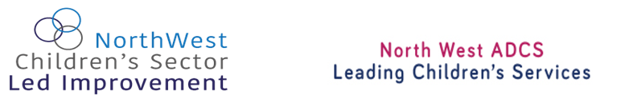

NWADCS Sector Led Improvement Offer
Sector Led Improvement
The NW region is ambitious for improvement in children’s services provision. Councils want to work together, and with others, to bring about the improvements required. They believe that a sector led approach will bring about sustainable change and much needed capacity. They contribute funding to operate a programme of support and challenge and they work with partners, including LGA, DFE and Ofsted in this important endeavour. The SLI offer is available to all 23 LAs and their political and corporate teams and is briefly listed below.

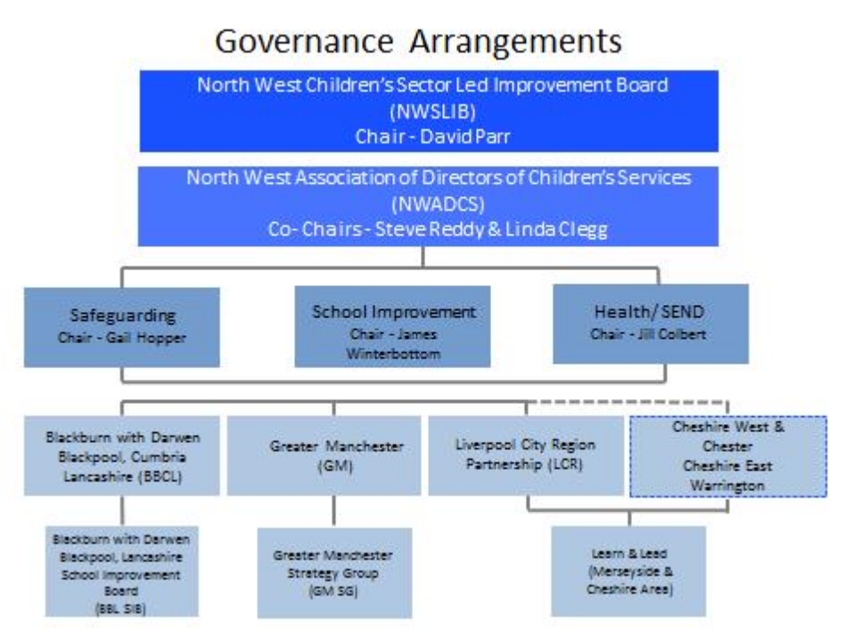

Annual Peer Challenge and Support Cycle

- Peer challenge and review for all 23 NW LAs
- LAs in 3 improvement alliances - Best Practice Networks (BPNs)
- Memorandum of Understanding underpins the process
- Self-evaluation completed as part of business planning cycle. Signed off by Lead Members and Chief Executives. Submitted in October.
- Matched against a regional data profile in November.
- Challenging questions agreed by BPN Leads for PC forums.
- PC forums in December 2017 and January 2018. DCSs leading the challenge with groups of colleagues.
- LA headlines compiled and actions shared with Lead Member
- Ofsted Annual Conversations follow on from PC forums. RSC 1-1 increasingly aligned.
- Identified good practice then shared in sector led workshops. Appropriate support brokered from within and outside of the region
- Getting to Good’ themes identified in partnership with Ofsted and appropriate lead LAs agreed.
- Regional themes progressed through leaders in the NWADCS sub groups.



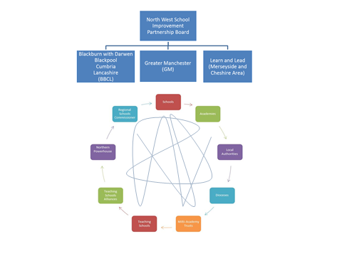
Best Practice Networks
The Local Authorities in the North West are grouped into three improvement alliances. This ensures a geographical and performance mix to facilitate challenge, learning and sharing.
BPN Blackburn with Darwen | BPN Trafford | BPN Rochdale
Oldham | Manchester | Cumbria
Lancashire | Liverpool | Bury
Salford | Cheshire East | Cheshire West & Chester
Wirral | Knowsley | Warrington
St Helens | Blackpool | Sefton
Tameside | Stockport | Bolton
Wigan | Halton

NWADCS Sub Groups
Three priority sub groups. Safeguarding, School Improvement, SEND. Chaired by DCSs and attended by ADs across the region. Take responsibility for the regional priorities and progress them in a sector led approach. Providing a pool of on-site peer challengers and improvement leads for sector led improvement. Reporting through DCS Chairs to NWADCS.
Getting to Good seminars
A programme of 4 repeated seminars devised in partnership with Ofsted regional team. Hosted by LAs and featuring two elements of good practice in the region. An input from Ofsted on what good looks like. Propose seminars 2017-18.
Working with Care Orders at Home - this session seeks to share system and practice responses to effectively manage the unique regional position where significant numbers of children subject of care orders and placed with their parents. Attendees should include Local Authority Children’s Social Care managers, LA Children’s Services legal representatives and Cafcass Managers and Guardians.
Systemic approaches to assessment and planning - a seminar which tackles the positive impact of a whole system approach to assessment and planning to meet the needs of children, young people and their families across the continuum of need. Attendees should include leaders and managers with responsibility for Early Help, Children’s Social Care and the work of Local Safeguarding Children Boards.
Delivering good practice in SEND - this half day event will focus on examples of quality SEND provision, particularly where key partners are playing an effective role. Ofsted colleagues will be joined by CQC for this session and there will be an analysis of what good looks like from recent inspections. Attendees should cover the spectrum of partners engaged in SEND provision including education, health, PVI settings.
Improving education outcomes through effective transition and robust partnership - a workshop with the author of the Ofsted report ‘KS3-the wasted years?' and featuring examples of effective all through provision. This seminar will examine the role of the LA in robust partnership working. Attendees should include Local Authority officers as well as partners representing schools and settings.

Regional Intelligence
Blackburn with Darwen’s Performance Lead has been commissioned to co-ordinate, with partners, the collection, collation and analysis of performance data (Education & Social Care Data and oversight of the Early Help data) for NW ADCS and key regional and sub-regional partners. This is the evidence platform on which the peer challenge process is based. The analysis provides the information on which improvements can be made by individual LAs and sub-regional groups. Soft intelligence is shared through the BPN structure.


Education Improvement
Created in 2013 to bring school improvement partners around the table, the NW School Improvement Partnership has recently provided the infrastructure for organising the Strategic School Improvement Fund submissions . The NWSIPB meets 5 times a year with an independent chair. There are 3 sub-regional groups - GM; Learn and Lead and BBCL who drive the education improvement activity. The implications of the RSC and TSC footprint will bring some changes. 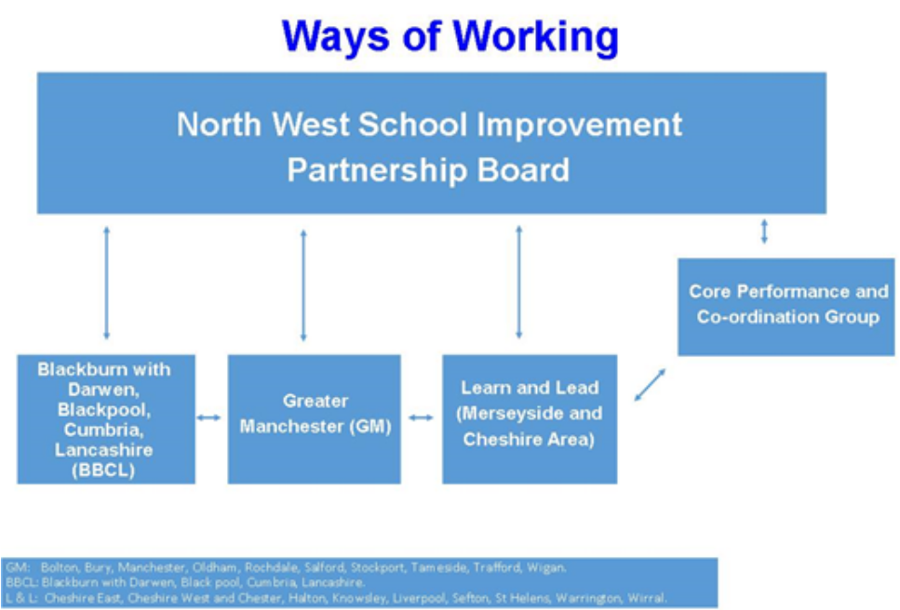

‘Working Together to Improve’
Bespoke support for those judged inadequate and those at risk (prevention). Support for LAs is discussed with LGA advisor to ensure support is coordinated. This group meets four times a year and comprises those LAs judged to be inadequate, supported by those who have previously been in similar position but are now judged to have improved. The informal networks continue outside of the meeting. LGA advisor and regional Ofsted team attend some meetings along with national leads or contributors with something useful to share.

Strategic Leads for Safeguarding and Vulnerable Children
- Comprehensive networking (click here for structure) - shaped around Putting Children First, driving strategic collaboration, improvement and change agendas.
- Regional Information Group - quarterly/annual benchmarking reports analysing and benchmarking areas of key performance in Children’s Social Care
- Performance Challenge sessions – including joint offer with LGA Improvement Adviser to deliver challenge sessions to leadership/management teams to support improvement activity or inspection readiness.
- Research in Practice Partnership - coordinating delivery of innovative partnership, supporting evidence-based practice and service development and delivery.
- NWADCS Protocols and Procedures - promoting safe and effective inter-authority placements, case transfer and information sharing; and consistent principles for social work assessment and supervision.

How do I find out more?
To find out more about our services or to discuss any support you may need,
please contact:

David Parr  Chair, North West Sector Led Improvement Board  Telephone: 0151 511 6000  Email: david.parr@halton.gov.uk | Steve Reddy  Co-Chair, NWADCS  Telephone: 01925 44 2900  Email: sreddy@warrington.gov.uk
Linda Clegg  Co-Chair, NWADCS  Telephone: 01254 666435  Email: Linda.clegg@blackburn.gov.uk | Maxine Froggatt  Programme Manager, Regional Sector Led Improvement Team  Telephone: 07977 535041  Email: maxinefroggatt@yahoo.co.uk
Paul Bunker  Regional Development Manager - Safeguarding and Vulnerable Children  Telephone: 07800 617738  Email: Paul.bunker@stockport.gov.uk | Zelda Massey  Regional Sector Led Improvement Team  Telephone: 0161 214 7108  Email: zeldam@nwemployers.org.uk

Support for DCSs
Peer to peer coaching and mentoring as part of Staff College offer and brokered within the region. Communications support, shared best practice, facilitated networking. Bespoke support.



