Jurys Inn & Leonardo hotels:
Diversity & Crisis Support 43 UK hotels in major city centre locations
As we all face a period of uncertainty with Coronavirus (COVID-19) continuing to spread I would like to update you on the various ways that we can help with critical action plans that can help the current state and the potential future impact if the situation continues to worsen.

We are in unprecedented territory so we would be willing to take unprecedented steps to support the national effort.

Please pass this information on to others who are involved with Crisis Support.

Hotel Diversity
Call Centres Temp HQ  Flexible space and facilities for any pop up call centre, 100’s off individual rooms allowing social distance between employees but allowing calls to continue.  Isolation possibilities allowing business and support to continue. | Isolation Hotels  Emergency Services & Rapid Response  We have city centre locations offering extensive facilities with large venue space and bedrooms that can be adapted for emergency services & rapid response teams providing safe sterile & isolated self-contained venues.
Medical Care / Hospitals:  We can adapt our hotels to provide temporary hospitals facilities. Individual bedrooms or ward facilities by utilisation of our meeting space. | Working from Home not possible!  Flexible workspace available, day let, short or long stays. We can offer an alternative work environment, which can be more productive than working from home. Individual safe & secure rooms, well-equipped allowing privacy and self-isolation.
Long Stay  Country border closure, flights grounded and other transportation not available has resulted in overseas visitors in the UK needing a place to live. Accommodation for long stay with extra amenities in rooms available. | Video Conferencing:  Secure video link ups and rooms available for use
Just let us know what you need
Craig Wilson
Director of Sales
Craig_Wilson@jurysinns.com
07976172248

Thomas Mcvay
Cluster Sales Executive
Thomas_Mcvay@leonardohotels.co.uk
07879657444
Jurys Inn & Leonardo Hotels UK and Ireland
UK Head Office, Jurys Inn Watford, 31-35 Clarendon Road, Watford, Hertfordshire, WD17 1JA
https://www.jurysinns.com/hotels
43 UK Hotels in every major UK city centre location.
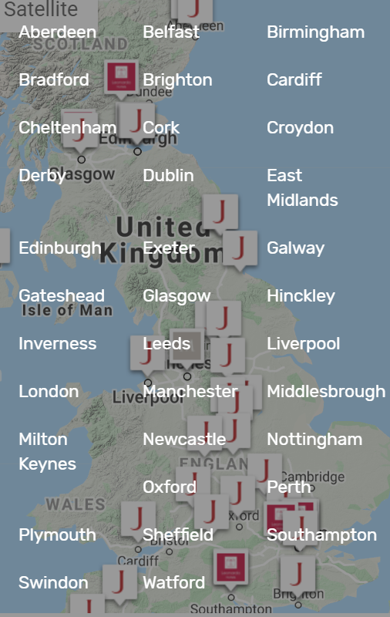
Safety is our priority
At Jurys Inn and Leonardo Hotels, our priority as always is the health and well-being of all our teams, their families and our guests. We are closely monitoring and reviewing the advice issued by national health organisations, as well as the World Health Organisation and we are taking all appropriate actions and precautionary measures within our hotels and across all of our operating offices.
These steps include:
Along with our usual cleaning protocols, deep cleaning is taking place daily across all hotels.
Hand sanitisers have been installed in various locations in our hotels along with information reiterating the steps to reduce spread including best handwashing practice.
We also conducted thorough briefings of all our customer-facing teams to ensure they are aware of the key steps to follow to help prevent the spread of Covid-19.
In addition, we have developed and regularly test our planning protocols to make sure we are fully ready to deal with a number of scenarios and risks that may arise, and which will allow us respond quickly if required.

